Zid’Avwa Al Bari’i
244107020083 / TI – 2I / 26
All the code here is on GitHub
https://github.com/ZidAvwa/CollegeStudy/tree/main/3rdSemester/13.%20Jobsheet13

Jobsheet 13

Experiment 1

Code
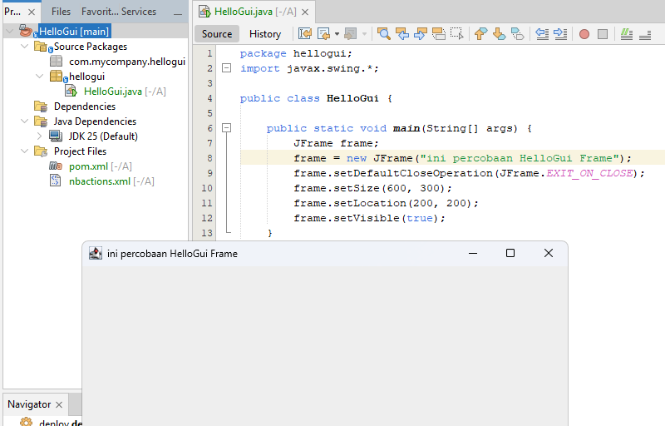

Experiment 2

Code
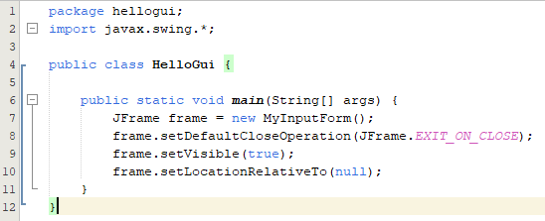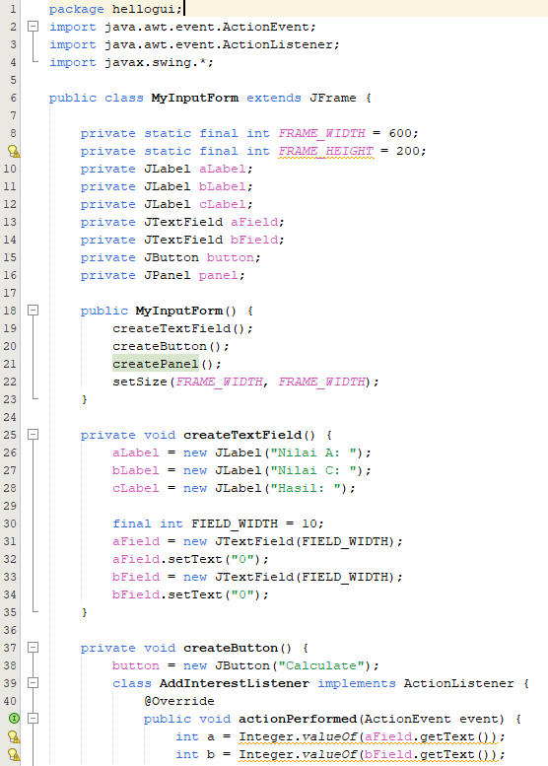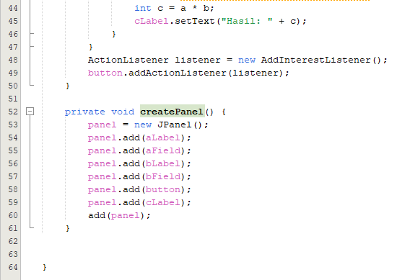

Question
Modify the program code by adding a new JButton to perform the addition calculation function, so that when the button is clicked (event click) it will display the addition results of the values A and B
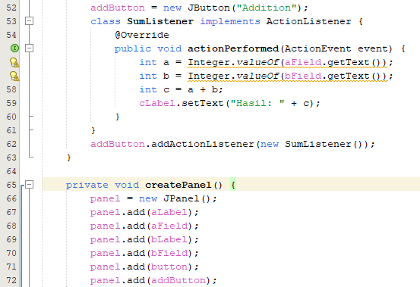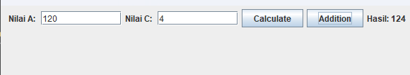
- Declared private JButton addButton; at the top.
- Inside createButton(): Added code to create the "Addition" button and a new listener (SumListener) that performs int c = a + b;.
- Inside createPanel(): Added panel.add(addButton); so the button actually shows up on the screen.

Experiment 3

Code
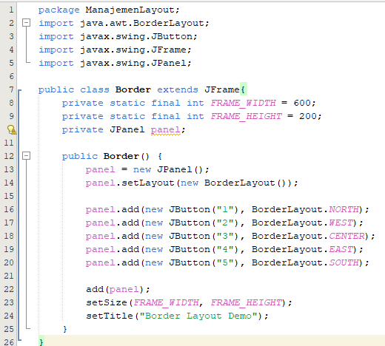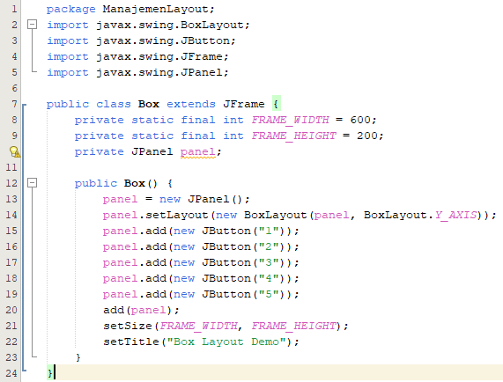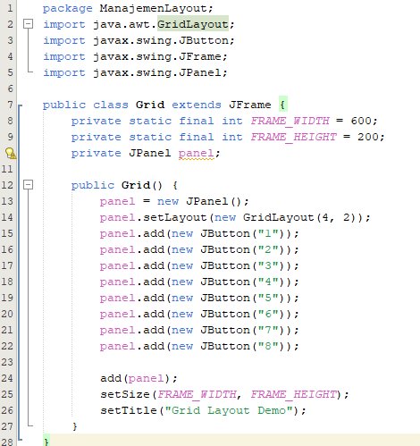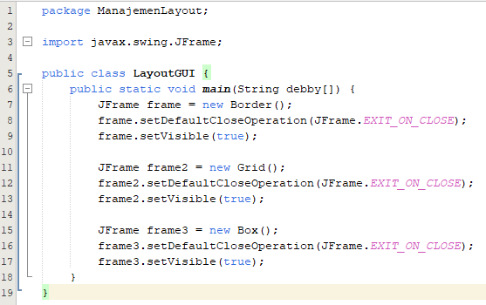
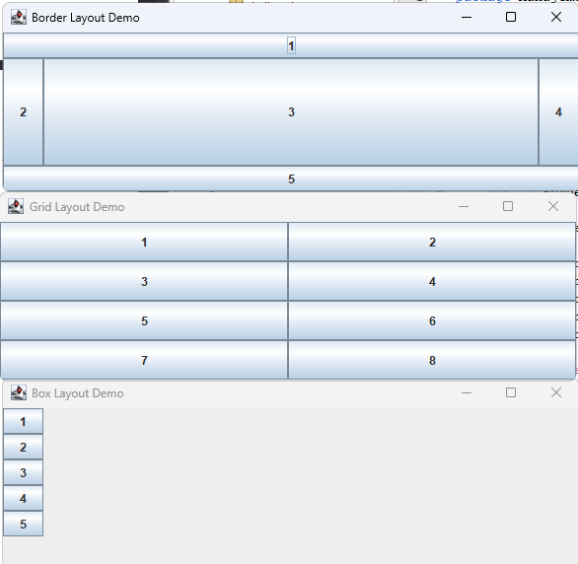

Question
- What is the difference between Grid Layout, Box Layout and Border Layout?
- BorderLayout: Divides the window into 5 fixed areas (North, South, East, West, Center).
- GridLayout: Arranges components in a grid of equal-sized cells.
- BoxLayout: Stacks components in a single straight line (either vertical or horizontal).
- What is the function of each of the following codes?
These lines create the window object for that specific layout, ensure the program actually stops running when you close the window, and make the window visible to the user.

Experiment 4

Code
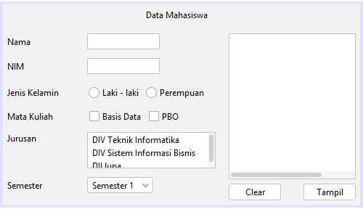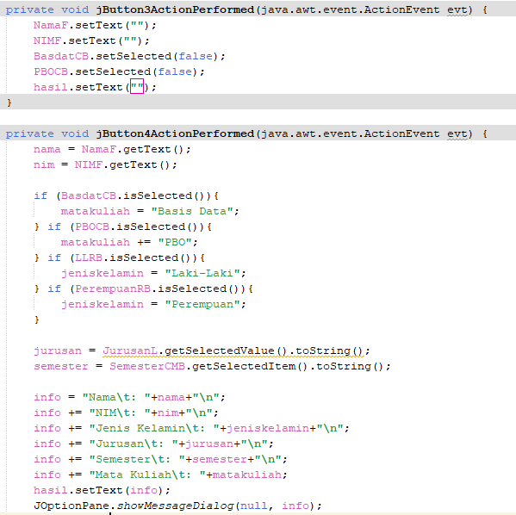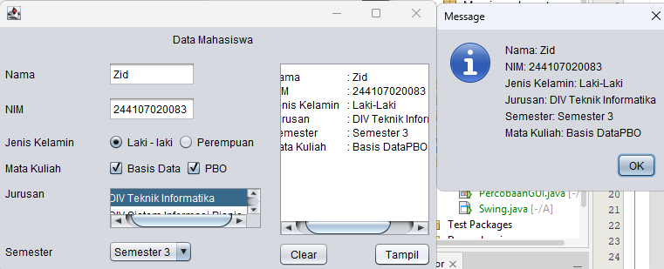

Questions
- It ensures the application starts safely and correctly.
- Because the radio buttons and checkbox have 2 state true and false
- Just add another text field (also declare variables and add in the clear button) and if logic like this
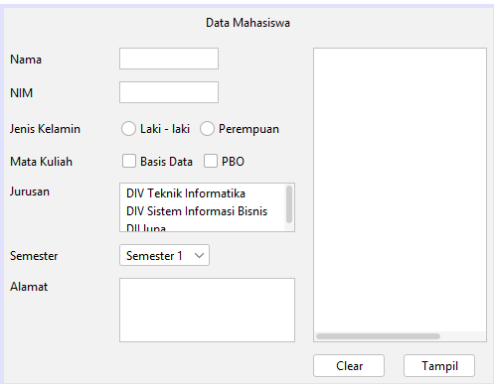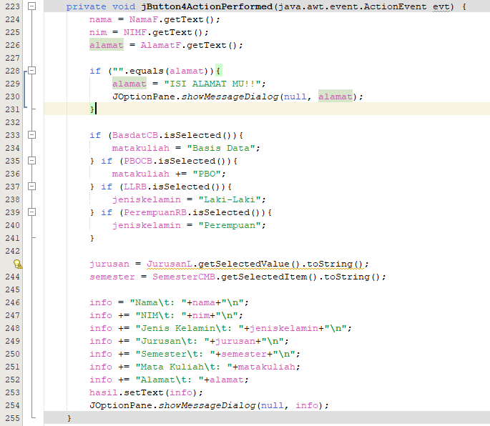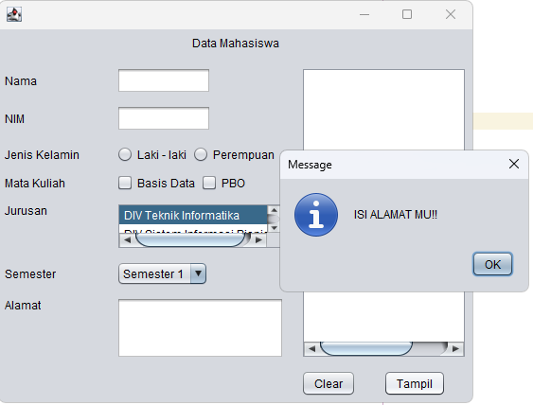

Experiment 5

Code
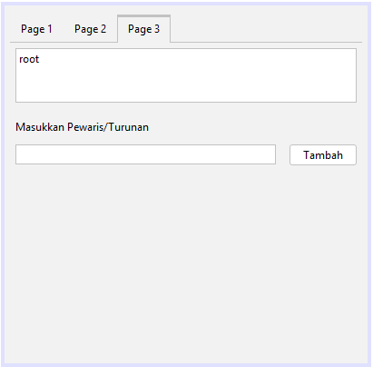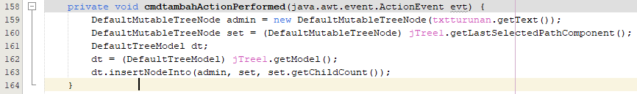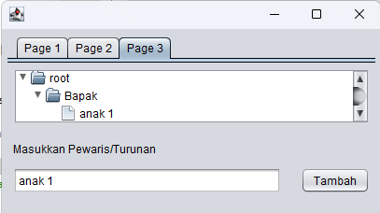

Questions
- To make tabs
- Just add the table like this
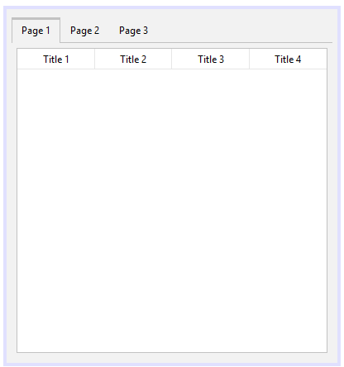

Assignment
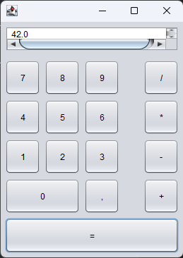 the program is on github https://github.com/ZidAvwa/CollegeStudy/tree/main/3rdSemester/13.%20Jobsheet13/Assignment

